- Program ID : VB001MA1

- Display Layout
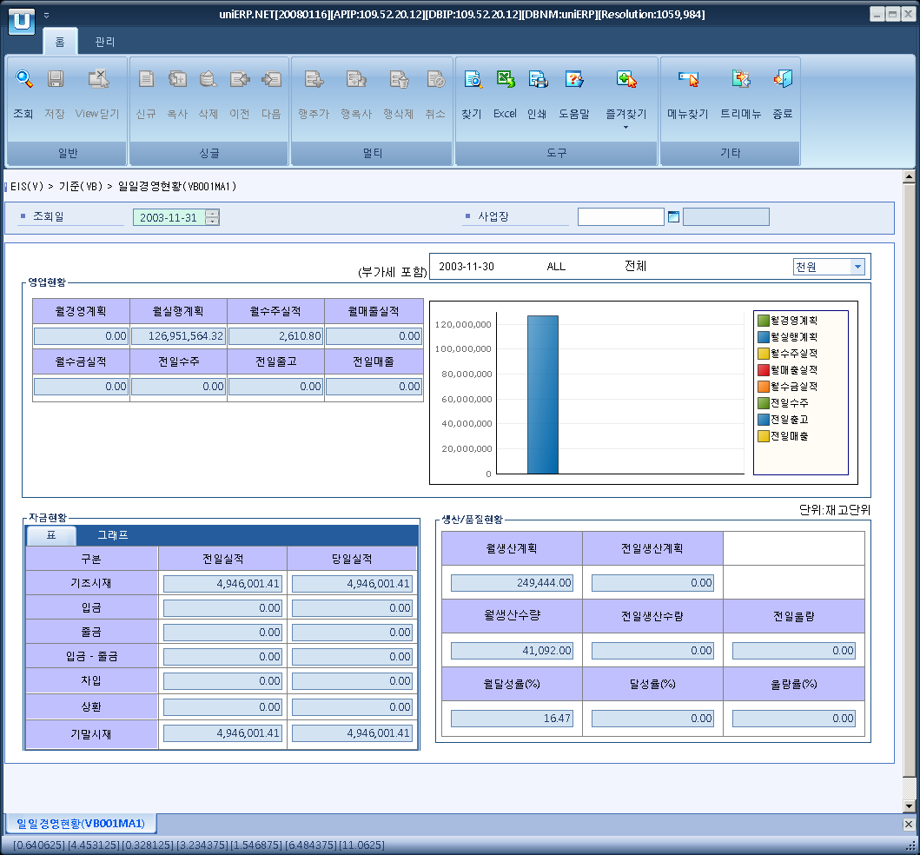

- Event flow
- Click Query button
- OnFncQuery -> DbQuery -> DataChange
- Display Unit combo change
- uniCombo1_ValueChanged -> DataChange

- SQL Statements
- Monthly management planning
SELECT ISNULL(SUM(m_plan), 0) AS m_plan,
ISNULL(SUM(e_plan), 0) AS e_plan,
ISNULL(SUM(mon_suju), 0) AS mon_suju,
ISNULL(SUM(mon_sale), 0) AS mon_sale,
ISNULL(SUM(mon_incm), 0) AS mon_incm,
ISNULL(SUM(yes_suju), 0) AS yes_suju,
ISNULL(SUM(yes_oucm), 0) AS yes_oucm,
ISNULL(SUM(yes_sale), 0) AS yes_sale
FROM (SELECT ISNULL(SUM(CASE a.sp_type WHEN 'M' THEN a.amt_loc END),0) AS m_plan, -- M: 경영 계획
ISNULL(SUM(CASE a.sp_type WHEN 'E' THEN a.amt_loc END),0) AS e_plan, -- E: 실행 계획
0 AS mon_suju, 0 AS mon_sale, 0 AS mon_incm, 0 AS yes_suju, 0 AS yes_oucm, 0 AS yes_sale FROM s_sp_item_by_bp a
INNER JOIN s_sp_period_info b
ON a.sp_period = b.sp_period
AND a.sp_type = b.sp_type
WHERE b.sp_year = SUBSTRING(@strDate, 1, 4)
AND b.sp_month = SUBSTRING(@strDate, 5, 2)
AND a.cfm_flag = 'Y'
AND a.sp_type IN ('M', 'E')
UNION ALL
SELECT 0, SUM(a.plan_amt) AS amt, 0, 0, 0, 0, 0, 0
FROM s_item_sales_plan a
WHERE a.sp_year = SUBSTRING(@strDate, 1, 4)
AND a.sp_month = SUBSTRING(@strDate, 5, 2)
AND a.cfm_flag = 'Y'
UNION ALL
SELECT 0, 0, ISNULL(SUM(CASE so_dt WHEN DATEADD(DD, -1, SUBSTRING(@strDate, 1, 6) + '01') THEN null
ELSE net_amt_loc + vat_amt_loc END), 0), -- 월간수주실적
0, 0, ISNULL(SUM(CASE so_dt WHEN DATEADD(DD, -1, @strDate) THEN net_amt_loc + vat_amt_loc
ELSE 0 END), 0), --전일 수주실적 0, 0
FROM s_so_hdr
WHERE so_dt BETWEEN DATEADD(DD, -1, SUBSTRING(@strDate, 1, 6) + '01')
AND @strDate
AND cfm_flag = 'Y'
UNION ALL
SELECT 0, 0, 0,
ISNULL(SUM(CASE bill_dt WHEN DATEADD(DD, -1, SUBSTRING(@strDate, 1, 6) + '01') THEN null
ELSE bill_amt_loc + vat_amt_loc END), 0), -- 월 매출 실적
ISNULL(SUM(CASE bill_dt WHEN DATEADD(DD, -1, SUBSTRING(@strDate, 1, 6) + '01') THEN null
ELSE collect_amt_loc END), 0), -- 월 수금 실적
0, 0, -- 전일 출고
ISNULL(SUM(CASE bill_dt WHEN DATEADD(DD, -1, @strDate) THEN bill_amt_loc + vat_amt_loc END),0)
FROM s_bill_hdr
WHERE bill_dt BETWEEN DATEADD(DD, -1, SUBSTRING(@strDate, 1, 6) + '01')
AND @strDate
AND post_flag = 'Y'

UNION ALL
SELECT 0,0,0,0,0,0,
SUM(CASE WHEN a.except_dn_flag = 'Y' THEN
CASE WHEN c.ret_item_flag = 'Y' THEN - (b.gi_amt_loc + b.vat_amt_loc)
ELSE b.gi_amt_loc + b.vat_amt_loc
END
ELSE
CASE WHEN d.ret_item_flag = 'Y' THEN - (b.gi_amt_loc + b.vat_amt_loc)
ELSE b.gi_amt_loc + b.vat_amt_loc END
END), 0
FROM s_dn_hdr AS a
INNER JOIN s_dn_dtl AS b
ON a.dn_no = b.dn_no
LEFT OUTER JOIN s_dn_sales AS c
ON a.dn_no = c.dn_no
LEFT OUTER JOIN (SELECT cur, ret_item_flag, so_no, so_dt
FROM s_so_hdr) AS d
ON b.so_no = d.so_no
WHERE a.dlvy_dt = DATEADD(dd, -1, @strDate)
AND a.post_flag = 'Y') a

- The Money status – the day before
SELECT ISNULL(SUM(bas_amt), 0), ISNULL(SUM(receipt_amt), 0), ISNULL(SUM(issue_amt), 0),
ISNULL(SUM(diff_amt), 0), ISNULL(SUM(loan_amt), 0), ISNULL(SUM(refund_amt), 0),
ISNULL(SUM(inv_amt), 0)
FROM va002at
WHERE sp_id = @strSpid
AND yyyymmdd = DATEADD(DD, -1, @strDate)

- The Money status - today
SELECT ISNULL(SUM(bas_amt), 0), ISNULL(SUM(receipt_amt), 0), ISNULL(SUM(issue_amt), 0),
ISNULL(SUM(diff_amt), 0), ISNULL(SUM(loan_amt), 0), ISNULL(SUM(refund_amt), 0),
ISNULL(SUM(inv_amt), 0)
FROM va002at
WHERE sp_id = @strSpid
AND yyyymmdd = @strDate

- Planned production - month
SELECT ISNULL(SUM(order_qty_in_base_unit), 0)
FROM p_production_order_header
WHERE plan_compt_dt >= LEFT(@strDate, 6) + '01'
AND plan_compt_dt < CONVERT(VARCHAR(6) ,DATEADD(MM, 1, @strDate), 112)
- Planned production - yesterday
SELECT ISNULL(SUM(order_qty_in_base_unit), 0)
FROM p_production_order_header
WHERE plan_compt_dt = DATEADD(DD, -1, @strDate)

- production output - month
SELECT ISNULL(SUM(a.prod_qty_in_base_unit), 0)
FROM p_production_results a
INNER JOIN p_production_order_detail b
ON a.prodt_order_no = b.prodt_order_no
AND a.opr_no = b.opr_no
AND b.rout_order IN ('S','L')
WHERE a.report_dt >= LEFT(@strDate, 6) + '01'
AND a.report_dt < CONVERT(VARCHAR(6) ,DATEADD(MM, 1, @strDate), 112)
AND a.del_flg = 'N'

- production output - yesterday
SELECT ISNULL(SUM(a.prod_qty_in_base_unit), 0)
FROM p_production_results a
INNER JOIN p_production_order_detail b
ON a.prodt_order_no = b.prodt_order_no
AND a.opr_no = b.opr_no
AND b.rout_order IN ('S','L')
WHERE a.report_dt = DATEADD(DD, -1, @strDate)
AND a.del_flg = 'N'

- bad goods - yesterday
SELECT ISNULL(SUM(P_PRODUCTION_RESULTS.INSP_BAD_QTY_IN_BASE_UNIT + CASE WHEN P_PRODUCTION_RESULTS.REPORT_TYPE = 'B' THEN P_PRODUCTION_RESULTS.PROD_QTY_IN_BASE_UNIT ELSE 0 END), 0)
FROM P_PRODUCTION_RESULTS, P_PRODUCTION_ORDER_DETAIL
WHERE P_PRODUCTION_RESULTS.PRODT_ORDER_NO = P_PRODUCTION_ORDER_DETAIL.PRODT_ORDER_NO
AND P_PRODUCTION_RESULTS.OPR_NO = P_PRODUCTION_ORDER_DETAIL.OPR_NO
AND P_PRODUCTION_RESULTS.REPORT_DT = DATEADD (DD, -1, @strDate)
AND P_PRODUCTION_ORDER_DETAIL.ROUT_ORDER IN ('S','L')
AND P_PRODUCTION_RESULTS.DEL_FLG = 'N'

